A LITTLE GIRL

A LITTLE GIRL, WITH EYES SO BRIGHT

A HEART OF GOLD AND A VIBE OF GLOWING LIGHT.

SHE LAUGHS AND PLAYS, A SUNSHINE DELIGHT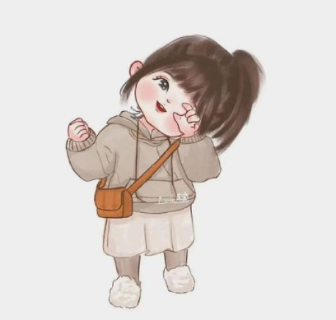.

A PRECIOUS GEM,PURE WHITE,

WITH INNOCENCE OF PEACE ROAMING AROUND

WITH ROSY CHEEKS AND SHINING HAIR,

SHE DANCES FREE,WITHOUT A CARE.

A PLAYFUL SOUL,BEYOND ANYTHING TO COMPARE

A LITTLE GIRL, SO SWEET AND PURELY FAIR.